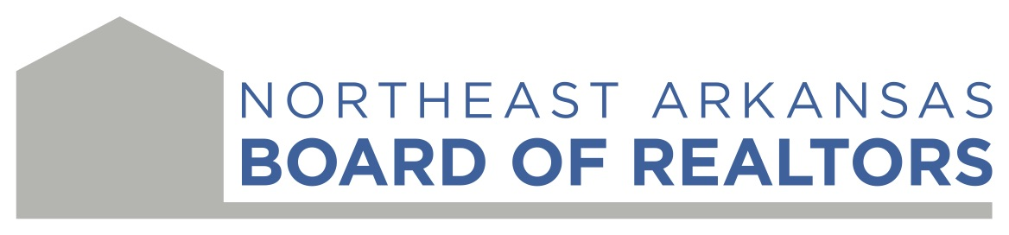
912 Congress Circle Jonesboro, AR 72401
Phone: 870-972-8425 Email: Office@neabor.com

Training Room Usage Agreement

The Northeast Arkansas Board of REALTORS® training room is available exclusively for members in good standing. Eligible members include Affiliates, Appraisers, and Primary REALTOR® Members.

Deposit/Cleaning Fee
Payment is required at the time of booking. Any costs related to damages, rule violations, or additional cleaning will be invoiced to you.

Key Holder Policy
The key will be released only to the individual who signed the usage agreement. The key holder must remain on-site for the entire duration of the room’s use.

Cancellation Policy
If you need to cancel your reservation, please contact the Board office as soon as possible. Cancellations made less than 48 hours before the scheduled event will incur a charge of 50% of the total reservation amount.

Do you understand the Deposit/Cleaning Policy?
- Yes
- No
- Yes
- No

Do you fully understand and agree to the Key Holder Policy?
- Yes
- No

Do you fully understand and agree to the Cancellation Policy?
- Yes
- No

Event & Room Information

Date of Rental: ______________________________________________________________

Event: ______________________________________________________________________

Event Time: __________________________________________________________________

Number of People Expected: ____________________________________________________

Lease Information

Membership Type: ____Realtor® ____Affiliate _____Appraiser

Name: _______________________________________________________________________

Brokerage/Business: _____________________________________________________________

Principal Broker/Manager: ________________________________________________________

Address: ______________________________________________________________________

Primary Phone Number: _________________________________________________________

Email address: _________________________________________________________________

Rule and Regulations
- No adhesives or fasteners of any kind may be used on walls, doors, or ceilings. This includes tape, push pins, staples, nails, screws, or any item that could puncture surfaces or leave residue.
- No glitter or confetti is permitted.
- The premises must be vacated at the designated end time.
- Improper conduct or lewd behavior is strictly prohibited.
- If alcoholic beverages are present, a waiver must be signed by every attendee age 21 or older. NEABOR will provide the waivers to the key holder.
- The facility and its furnishings must be left in clean condition at the end of the rental period.
- Refreshments located in the kitchen are not permitted for use.
- The cleaning checklist must be completed and signed by the key holder.
- All cleanup is the responsibility of the lease holder/key holder, including placing all trash in the outside dumpster.
Alcohol Policy
If alcoholic beverages are present, a waiver must be signed by every attendee age 21 or older. Failure to obtain signed waivers may affect eligibility for future rentals. NEABOR will provide waiver forms to the key holder. All alcohol is strictly bring-your-own. The Board office will not supply, purchase, or store alcoholic beverages for any event.
Decorations/Entertainment

Decorations are allowed within the rules listed above.

Entertainment is allowed within the rules listed above.

Confetti/Sparklers/Glitter/Candles
Confetti, Sparklers, and burning candles are NOT permitted.

Supervision
The key holder/lease must remain present during the entirety of the room usage.

Facility Clean Up Rules & Procedures

- All cleanup is the responsibility of the key holder/lease holder and must be completed within the rental time frame. This includes sweeping, mopping, and cleaning tables.
- The facility must be left in the same condition as when the rental began.
- All garbage must be bagged and disposed of in the outside dumpster.
- All tables and chairs must be wiped clean and returned to their original locations.
- The kitchen must be left clean: counters wiped, sink emptied, leftover food removed, and the microwave and refrigerator cleaned.
- Refreshments must be supplied by the key holder/lease holder. Refreshments located in the kitchen may not be used.
- The cleaning checklist must be completed, signed, and placed in the mailbox along with the building key at the end of the event.

FUNCTIONS WILL BE STOPPED AND KEY HOLDER/LEASE AND ALL OTHER PRESENT MADE TO LEAVE IF NOT FOLLOWING THE RULES, IF KEY HOLDER IS NOT PRESENT, IF PROPERTY IS DAMAGED, ETC. THE NORTHEAST ARKANSAS BOARD OF REALTORS® EXECUTIVE BOARD OR STAFF MEMBERS HAVE THE AUTHORITY TO END FUNCTION AT ANY SAID TIME DUE TO THE ABOVE MENTIONED.

_________________________________________________ _________________
Key Holder/Lease Signature Date

_________________________________________________ _________________
Principal Broker/Manager Signature Date

_______________________*NEABOR STAFF ONLY*________________________

Date Approved: ________________________________________________________________

Signature: ____________________________________________________________________

